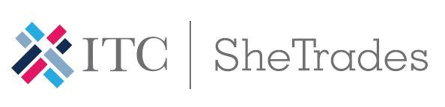
SHETRADES EXPORT SWOT ANALYSIS

Name: | Company Name: |  |  | Sector:
ANALYSIS OBJECTIVES
INTERNAL FACTORS
STRENGTHS (+) |  |  | WEAKNESSES (-)
EXTERNAL FACTORS
OPPORTUNITIES (+) |  |  | THREATS (-)
ANALYSIS SUMMARY |  |  | ACTIONS TO BE UNDERTAKEN

